Project Design Phase-II
Technology Stack (Architecture & Stack)
Date | 27/09/2026
Team ID | SWTID-2026-7148
Project Name | AI Weatherwise API
Maximum Marks | 4 Marks

Technical Architecture:
The Deliverable shall include the architectural diagram as below and the information as per the table1 & table 2
Example: Order processing during pandemics for offline mode
Reference: https://developer.ibm.com/patterns/ai-powered-backend-system-for-order-processing-during-pandemics/
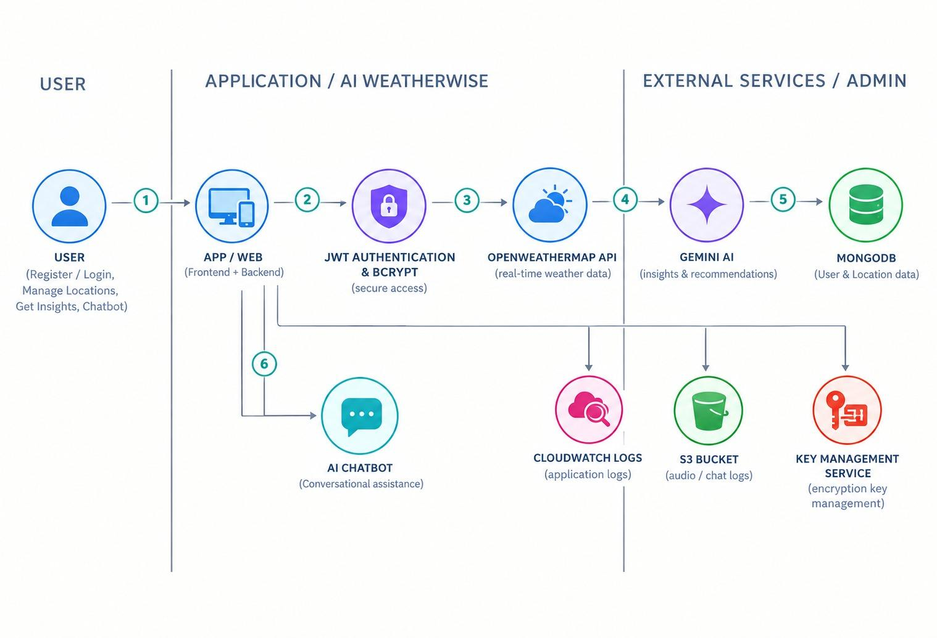

Table-1 : Components & Technologies:

S.No | Component | Description | Technology
1 | User Interface | Backend REST API through which users interact with the application. The project does not include a separate frontend. | Node.js, Express.js
2 | Application Logic-1 | Handles user registration, login, JWT authentication, and password security. | Node.js, Express.js, JWT, bcryptjs
3 | Application Logic-2 | Handles weather information retrieval and favorite location functionality. | Node.js, Express.js, OpenWeather API
4 | Application Logic-3 | Handles AI-generated weather summaries, recommendations, and chatbot responses. The chatbot reuses the existing Gemini AI package and AI service structure. | Gemini AI
5 | Database | Stores application data such as user and favorite location information. No separate chatbot database model or conversation history storage is used. | MongoDB, Mongoose
6 | Cloud Database | No separate cloud database service is used for the chatbot feature. | Existing MongoDB setup
7 | File Storage | Configuration such as the Gemini API key is maintained through the .env file. | Local environment configuration
8 | External API-1 | Provides weather information for requested locations. | OpenWeather API
9 | External API-2 | Provides generative AI processing for weather summaries, recommendations, and chatbot responses. | Gemini AI
10 | Machine Learning Model | No separate machine learning model is created. AI-generated responses are provided using the existing Gemini AI integration. | Gemini AI
11 | Infrastructure (Server / Cloud) | Backend REST API runs on the local Node.js server during development and testing. | Node.js, Express.js

Table-2: Application Characteristics:

S.No | Characteristics | Description | Technology
1 | Open-Source Frameworks | Open-source frameworks and libraries are used to build the backend REST API and connect with external services. | Node.js, Express.js, Mongoose
2 | Security Implementations | User authentication is protected using JWT, passwords are handled using bcryptjs, and the Gemini API key is read from the .env file. The chatbot endpoint is also protected by the existing JWT authentication middleware. | JWT, bcryptjs, .env
3 | Scalable Architecture | The backend is implemented as a REST API with separate routes, controllers, and AI service logic. The chatbot reuses the existing AI service without requiring a new database model or frontend. | Node.js, Express.js, Gemini AI
4 | Availability | The API is available when the local backend server and required external services such as OpenWeather API and Gemini AI are available. Appropriate error handling and fallback responses are provided for Gemini/API failures. | Node.js, Express.js, OpenWeather API, Gemini AI
5 | Performance | The application processes weather and AI requests through REST API endpoints. The chatbot sends the user message to the existing Gemini AI service and returns the generated response. | Express.js, OpenWeather API, Gemini AI

References:
https://c4model.com/
https://developer.ibm.com/patterns/online-order-processing-system-during-pandemic/
https://www.ibm.com/cloud/architecture
https://aws.amazon.com/architecture
https://medium.com/the-internal-startup/how-to-draw-useful-technical-architecture-diagrams-2d20c9fda90d

